RESOLUTION NO.__________

RE: CERTIFICATE OF APPROPRIATENESS UNDER THE
PROVISIONS OF THE ACT OF THE PENNSYLVANIA
LEGISLATURE 1961, JUNE 13, P.L. 282 (53
SECTION 8004) AND BETHLEHEM ORDINANCE NO.
3952 AS AMENDED.

WHEREAS, it is proposed to paint building & trim, replace awning, install lighting and remove rear tent and replace with pergolas at 313 E Third Street.

NOW, THEREFORE, BE IT RESOLVED by the Council of the City of Bethlehem that a Certificate of Appropriateness is hereby granted for the work.

Sponsored by: (s)

(s)

ADOPTED BY COUNCIL THIS DAY OF

(s)
President of Council

ATTEST:

(s)
City Clerk

HISTORIC CONSERVATION COMMISSION

CASE # 555 – It is proposed to paint building & trim, replace awning, install lighting and remove rear tent and replace with pergolas at 313 E Third Street
OWNER/APPLICANT: Jeannie Agentis Revocable Living Trust/ Bill & Sue Dech

The Commission upon motion by Mr. Lader seconded by Mr. Lousch adopted the proposal that City Council issue a Certificate of Appropriateness for the proposed work described herein:
- The proposal to paint building & trim, replace awning, install lighting and remove rear tent and replace with pergolas at 313 E Third Street was presented by Bill & Sue Dech.
- The existing awning will be replaced with a new black awning with the “Southside 313” sign and logo in “Greek Villa” color on the slope of the awning. Scaled drawings must be submitted to the Historic Officer for review. The fabric must be a Sunbrella-like canvas.
- Three black goose neck lights will be installed into the stucco above the awning.
- The existing outside rear tent will be replaced with pergolas constructed in wood with a clear corrugated covering. The pergolas were approved in concept only, and scaled design and structural drawings must be submitted for review by the HCC at a future meeting.
- The exterior of the building may be painted. Although the HCC does not regulate paint colors, it is strongly recommended to modify the proposed paint scheme so that the darkest color (Seal Skin) is used for the body of the building and the window trim. The medium tan color (Dormer Brown) is recommended for the Classical storefront with accents of Seal Skin and Greek Villa. This is only a recommendation and not a requirement.
- The proposed motion was unanimously approved.

CU: cu
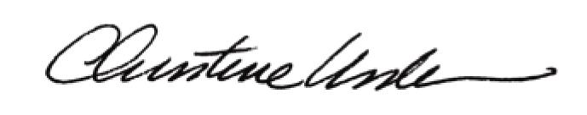

By:

Date of Meeting: June 15, 2015 Title: Historic Officer

